**Software Requirements Specification (SRC)**

**Project Title: Hotel Booking**

**Requirements:**

We need to build a software for “Hotel Booking”. The application will have following features:

1. There will be different type users like Admin, customers, cashier, operator etc.
2. There will be ‘Home page’, ‘Service’, ‘Room Booking’, ‘Gallery page’, ‘About page’ and ‘Login page’ etc.
3. In login page, admin, customers and receptionist’s views.
4. From service page customer can find his available facilities. He/she can his suitable room.
5. From room booking page customer can select his room booking details. He/she can have facility to book the room check in and check out time.
6. In Gallery page customers can see room details. All the information about room will be presented there.
7. In about page there will be information about hotel owner’s details.

Analysis and Design Part:

1. Brain Storming Diagram:

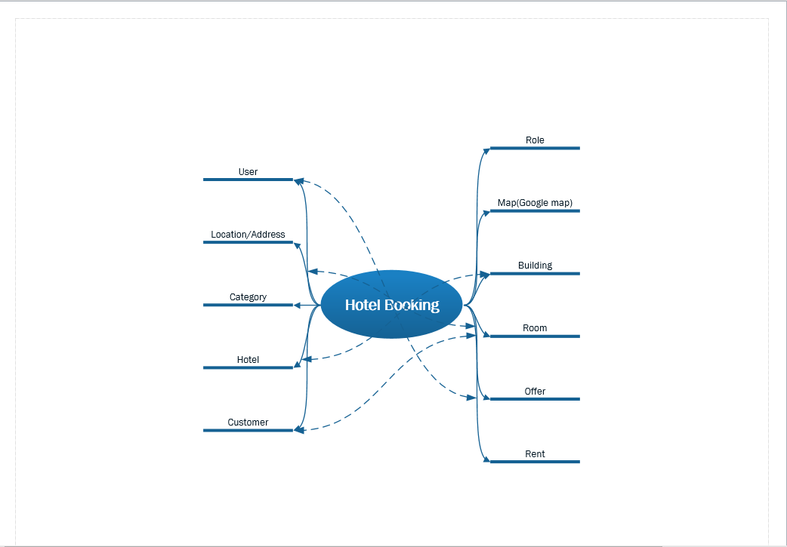

1. Use Case Diagram:

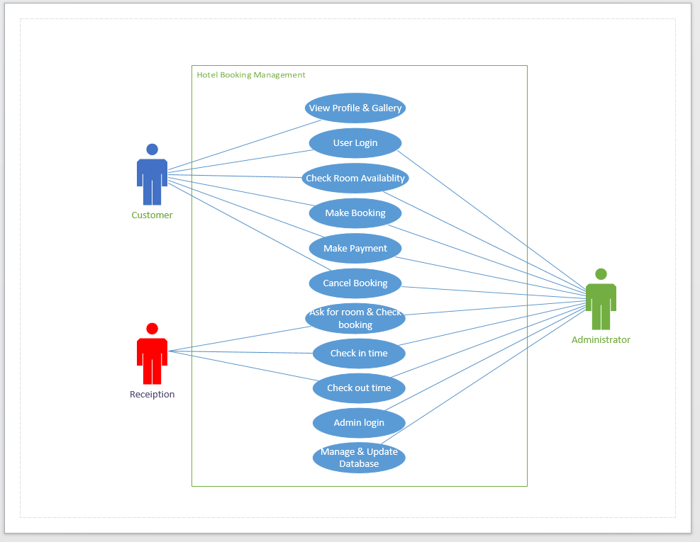

1. Class Diagram: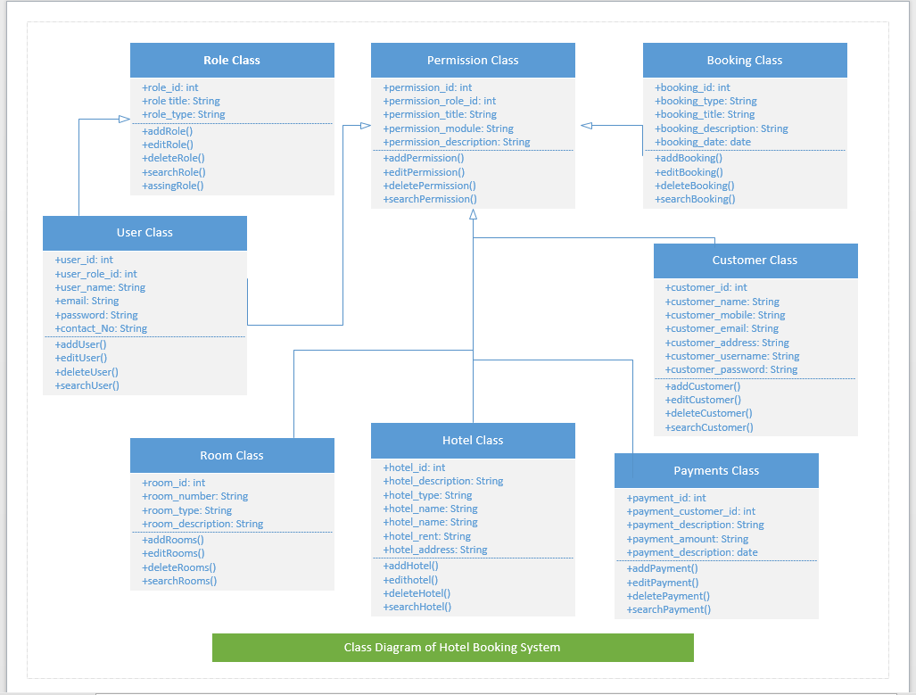
2. Entity Relationship Diagram:
3. Front End Designs: